**Basics of Preventive Maintenance and Troubleshooting**

**Objectives**

Upon completion of this chapter, you should be able to answer the following questions:

n

What is the purpose of preventive maintenance?

n

What are the elements of the troubleshooting

process?

**Key Terms**

This chapter uses the following key terms. You can find the definitions in the Glossary.

*page 104*

*preventive maintenance*

*tr*

*page 104*

*oubleshooting*

*backup*

*page 107*

*open-ended questions*

*page108*

*page 108*

*closed-ended questions*

*page 109*

*Event Viewer*

*Device Manager*

*page 110*

*power-on self test (POST)*

*page110*

103

.qxp 8/20/10 1:37 PM Page

9781587132636_ch04

This chapter introduces preventive maintenance and the troubleshooting process. This chap-

ter discusses troubleshooting as a concept. Detailed troubleshooting techniques are outlined

in subsequent chapters as they apply to specific software and devices.

***Preventive maintenance***

is a regular and systematic inspection, cleaning, and replacement

of worn parts, materials, and systems. Preventive maintenance helps to prevent failure of

parts, materials, and systems by ensuring that they are in good working order.

***Troubleshooting***

is a systematic approach to locating the cause of a fault in a computer sys-

tem. A good preventive maintenance program helps minimize failures. With fewer failures,

there is less troubleshooting to do, thus saving an organization time and money. Preventive

maintenance can also include upgrading certain hardware or software such as a hard drive

that is making noise, upgrading memory that is insufficient, or installing software updates

for security or reliability.

Troubleshooting is a learned skill. Not all troubleshooting processes are the same, and

technicians tend to refine their troubleshooting skills based on knowledge and personal

experience. Use the guidelines in this chapter as a starting point to help develop your

troubleshooting skills. Although each situation is different, the process described in this

chapter will help you to determine your course of action when you are trying to solve a

technical problem for a customer.

**Explain the Purpose**

**of Preventive Maintenance**

Preventive maintenance reduces the probability of hardware or software problems by sys-

tematically and periodically checking hardware and software to ensure proper operation.

**Hardware**

Checkthe condition of cables, components, and peripherals. Clean components to reduce

the likelihood of overheating. Repair or replace any components that show signs of damage

or excessive wear.

Use the following tasks as a guide to create a hardware maintenance program:

n

Remove dust from fan intakes.

n

Remove dust from the power supply.

n

Remove dust from components inside the computer.

n

Clean the mouse and keyboard.

n

Check and secure loose cables.

104

IT Essentials: PC Hardware and Software Companion Guide

**Software**

Verify that installed software is current. Follow the policies of the organization when

installing security updates, operating system updates, and program updates. Many organiza-

tions do not allow updates until extensive testing has been completed. This testing is done

to confirm that the update will not cause problems with the operating system and software.

Use the tasks listed as a guide to create a software maintenance schedule that fits the needs

of your computer equipment:

n

Review security updates.

n

Review software updates.

n

Review driver updates.

n

Update virus definition files.

n

Scan for viruses and spyware.

n

Remove unwanted programs

n

Scan hard drives for errors.

n

Defragment hard drives.

**Benefits**

Be proactive in computer equipment maintenance and data protection. By performing

regular maintenance routines, you can reduce potential hardware and software problems.

Regular maintenance routines reduce computer downtime and repair costs.

A

preventive maintenance plan is developed based on the needs of the equipment. A com-

puter exposed to a dusty environment, such as a construction site, needs more attention than

equipment in an office environment. High-traffic networks, such as a school network, might

require additional scanning and removal of malicious software or unwanted files. Document

the routine maintenance tasks that must be performed on the computer equipment and the

frequency of each task. This list of tasks can then be used to create a maintenance program.

The following are the benefits of preventive maintenance:

n

Increases data protection

n

Extends the life of the components

n

Increases equipment stability

n

Reduces repair costs

n

Reduces the number of equipment failures

Chapter 4: Basics of Preventive Maintenance and Troubleshooting

105

**Identify the Steps of the Troubleshooting**

**Process**

Troubleshooting requires an organized and logical approach to problems with computers

and other components. A logical approach to troubleshooting allows you to eliminate vari-

ables in a systematic order. Asking the right questions, testing the right hardware, and

examining the right data helps you understand the problem. This helps you form a proposed

solution to try.

Troubleshooting is a skill that you will refine over time. Each time you solve another prob-

lem, you will increase your troubleshooting skills by gaining more experience. You will

learn how and when to combine, as well as skip, steps to reach a solution quickly. The fol-

lowing troubleshooting process is a guideline that you can modify to fit your needs.

n

Explain the purpose of data protection.

n

Identify the problem.

n

Establish a theory of probable causes.

n

Test the theory to determine an exact cause.

n

Establish a plan of action to resolve

the problem and implement the solution.

n

Verify full system functionality, and if applicable, implement preventive measures.

n

Document findings, actions, and outcomes.

In this section, you will learn an approach to problem solving that can be applied to both

hardware and software. You also can apply many

of the steps to problem solving in other

work-related areas.

**Note**

The term customer, as used in this book, is any user who requires technical computer assistance.

**Explain the Purpose of Data Protection**

Before you begin troubleshooting problems, always follow the necessary precautions to

protect data on a computer. Some repairs, such as replacing a hard drive or reinstalling an

operating system, might put the data on the computer at risk. Make sure that you do every-

thing possible to prevent data loss while attempting repairs.

**Caution**

Although data protection is not one of the six troubleshooting steps, you must protect data before

beginning anyw

ork on a customer’s computer. If your work results in data loss for the customer, you

or your company could be held liable.

106

IT Essentials: PC Hardware and Software Companion Guide

Data Backup

A

data

***backup***

is a copy of the data on a computer hard drive that is saved to media such as

a

CD, DVD, or tape drive. In an organization, backups are routinely done on a daily, week-

ly, and monthly basis.

If you are unsure that a backup has been done, do not attempt any troubleshooting activities

until you check with the customer. Here is a list of items to verify with the customer about

data backups:

n

Date of the last backup

n

Contents of the backup

n

Data integrity of the backup

n

Availability of all backup media for a data restore

If the customer does not have a current backup and you are not able to create one, you

should ask the customer to sign a liability release form. A liability release form should con-

tain at least the following information:

n

Permission to work on the computer without a current backup available

n

Release from liability if data is lost or corrupted

n

Description of the work to be performed

**Identify the Problem**

During

the troubleshooting process, gather as much information from the customer as possi-

ble. The customer should provide you with the basic facts about the problem. Here is a list

of some of the important information to gather from the customer:

n

Customer information

—

Company

name

—Contact name

—Address

—Phone number

n

Computer configuration

—Manufacturer and model

—Operating system information

—Network environment

—Connection type

Chapter 4: Basics of Preventive Maintenance and Troubleshooting

107

n

Description of problem

—Open-ended questions

—Closed-ended questions

Conversation Etiquette

When youare talking to the customer, you should follow these guidelines:

n

Ask direct questions to gather information.

n

Do not use industry jargon when talking to customers.

n

Do not talk down to the customer.

n

Do not insult the customer.

n

Do not accuse the customer of causing the problem.

By communicating effectively, you will be able to elicit the most relevant information about

the problem from the customer.

Open-Ended Questions

When gathering information from customers, use both open-ended and closed-ended ques-

tions. Start with

***open-ended questions***

to obtain general information. Open-ended questions

allow

customers to explain the details of the problem in their own words. Some examples of

open-ended questions are

n

What problems are you experiencing with your computer or network?

n

What software has been installed on your computer recently?

n

What were you doing when the problem was identified?

n

What hardware changes have recently been made to your computer?

Closed-Ended

Questions

Based on the information from the customer, you can proceed with closed-ended questions.

***Closed-ended questions***

generally require a yes or no answer. These questions are intended

to get the most relevant information in the shortest time possible. Some examples of closed-

ended questions are

n

Has anyone else used your computer recently?

n

Can you reproduce the problem?

n

Have you changed your password recently?

108

IT Essentials: PC Hardware and Software Companion Guide

n

Have you received any error messages on your computer?

n

Are you currently logged in to the network?

Documenting Responses

Document the information obtained from the customer in the work order and in the repair

journal. Write down anything that you think might be important for you or another techni-

cian. Often, the small details can lead to the solution of a difficult or complicated problem.

It is now time to verify the customer’s description of the problem by gathering data from

the computer.

Event Viewer

When system, user, or software errors occur on a computer,

***Event Viewer***

is updated with

information about the errors. The Event Viewer application shown in Figure 4-1 records the

following information about the problem:

n

What problem occurred

n

Date and time of the problem

n

Severity of the problem

n

Source of the problem

n

Event ID number

n

Which user was logged in when the problem occurred

**Figure 4-1**

Event Viewer

109

Chapter 4: Basics of Preventive Maintenance and Troubleshooting

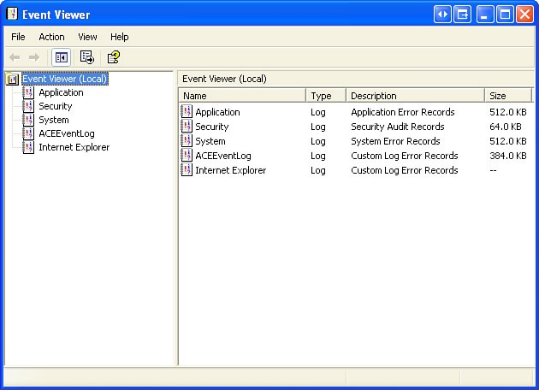

Although Event Viewer lists details about the error, you might need to further research the

solution.

Device Manager

***Device Manager***

,

shown in Figure 4-2, displays all of the devices that are configured on a

computer. Any device that the operating system determines to be acting incorrectly is

flagged with an error icon. This type of error has a yellow circle with an exclamation point

(!)

. If a device is disabled, it is flagged with a red circle and an ?. A yellow question mark

(

?) indicates that the hardware is not functioning properly because the system does not

know which driver to install for the hardware.

**Figure 4-2**

Device Manager

110

IT Essentials: PC Hardware and Software Companion Guide

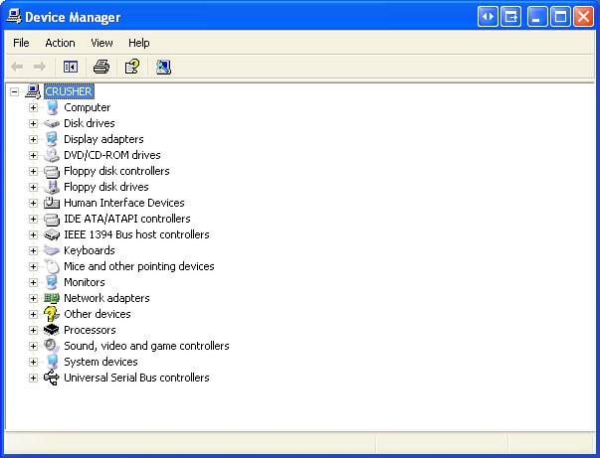

Beep Codes

Each BIOS manufacturer has a unique beep sequence for hardware failures. When trou-

bleshooting, power on the computer and listen. As the system proceeds through the

***power-***

***on self test (POST)***

,

most computers emit one beep to indicate that the system is booting

properly.

If there is an error,

you might hear multiple beeps. Document the beep code

sequence, and research the code to determine the specific hardware failure.

BIOS

Information

If the computer boots and stops after the POST, investigate the BIOS settings to determine

where to find the problem. A device might not be detected or configured properly. Refer to

the motherboard manual to make sure that the BIOS settings are accurate.

Chapter 4: Basics of Preventive Maintenance and Troubleshooting 111

# Diagnostic Tools

Conduct research to determine which software is available to help diagnose and solve problems. There are many programs available that can help you troubleshoot hardware. Often, manufacturers of system hardware provide diagnostic tools of their own. For instance, a hard drive manufacturer might provide a tool that you can use to boot the computer and diagnose why the hard drive does not boot Windows.

# Establish a Theory of Probable Causes

First, create a list of the most common reasons why the error would occur. Even though the customer may think that there is a major problem, start with the obvious issues before moving to more complex diagnoses. List the easiest or most obvious causes at the top and the more complex causes at the bottom. You will test each of these causes in the next steps of the troubleshooting process.

# Test the Theory to Determine an Exact Cause

The next step in the troubleshooting process is to determine an exact cause. You determine an exact cause by testing your theories of probable causes one at a time, starting with the quickest and easiest. After identifying an exact cause of the problem, determine the steps to resolve the problem. As you become more experienced at troubleshooting computers, you will work through the steps in the process faster. For now, practice each step to better understand the troubleshooting process.

If the exact cause of the problem has not been determined after you have tested all your theories, establish a new theory of probable causes and test it. If necessary, escalate the problem to a technician with more experience. Before you escalate, document each test that you try. Information about the tests is vital if the problem needs to be escalated to another technician. Many third-party tools are free to download.

# Implement the Solution

After you have determined the exact cause of the problem, establish a plan of action to resolve the problem and implement the solution. Sometimes quick procedures can determine the exact cause of the problem or even correct the problem. If a quick procedure does correct the problem, you can go to step 5 to verify the solution and full system functionality. If a quick procedure does not correct the problem, you might need to research the problem further to establish the exact cause. When researching possible solutions for a problem, use the following sources of information: n Your own problem-solving experience n Other technicians

n

Internet search

n

Newsgroups

n

Manufacturer FAQs

n

Computer manuals

n

Device manuals

n

Online forums

n

Technical websites

Evaluate the problem and research possible solutions. Divide larger problems into smaller

problems that can be analyzed and solved individually. Prioritize solutions starting with the

easiest and fastest to implement. Create a list of possible solutions and implement them one

at a time. If you implement a possible solution and it does not work, reverse the solution

and try another.

**Verify Solution, Full System Functionality, and If**

**Applicable, Implement**

**Preventive Measures**

Afterthe repairs to the computer have been completed, continue the troubleshooting

process by verifying full system functionality and implementing any preventive measures if

needed. Verifying full system functionality confirms that you have solved the original prob-

lem and ensures that you have

not created another problem while repairing the computer.

Whenever possible, have the customer verify the solution and system functionality.

**Document Findings, Actions, and Outcomes**

Finishthe troubleshooting process by closing with the customer. Communicate the problem

and the solution to the customer verbally and in writing. If possible, demonstrate how your

solution has solved the problem. Be sure to complete the documentation, which should

include the following information:

n

Description of the problem

n

Steps to resolve

the problem

n

Components used in the repair

112

IT Essentials: PC Hardware and Software Companion Guide

113

Chapter 4: Basics of Preventive Maintenance and Troubleshooting

**Summary**

This chapter discussed the concepts of preventive maintenance and the troubleshooting

process, including the following important points:

n

Regular preventive maintenance reduces hardware and software problems.

n

Before beginning any repair, back up the data on a computer.

n

The troubleshooting process is a guideline to help you solve computer problems in an

efficient manner.

n

Document everything that you try, even if it fails. The documentation that you create

will become a useful resource for you and other technicians.

**Summary of Exercises**

There are no Labs, Worksheets, Remote Technician exercises, Class Discussions, Virtual

Desktop activities, or Virtual Laptop activities associated with this chapter.

**Check Your Understanding**

You can find the answers to these questions in the appendix, “Answers to Check Your

Understanding Questions.”

**1.**

Which of the following common tasks are performed during preventive maintenance?

(

Choose three.

)

A.

Check and secure loose cables.

B.Update the RAM.

C.Clean the mouse and keyboard.

D.Update drivers.

E.

Reinstall the operating system.

F.Install additional peripherals.

**2.**

In which of the following situations is it recommended to ask the customer to sign a

liability release form before attempting any kind of repair? (Choose two.)

A.

The technician needs to share the responsibility with the customer.

B.The information on the computer is critical.

C.The technician is unable to back up the customer information.

D.

The information in the backup is confidential.

E.The customer is unable to provide a backup.

113

.qxp 8/20/10 1:37 PM Page

9781587132636_ch04

114

IT Essentials: PC Hardware and Software Companion Guide

**3.**

What is the first step in the troubleshooting process?

A.Gather data from the computer.

B.Gather data from the customer.

C.Verify the obvious issues.

D.Evaluate the problem and implement the solution.

E.Close with the customer.

F.Try quick solutions.

**4.**

Which type of question allows the customer to completely describe the problem?

A.Closed-ended

B.Open-ended

C.Specific

D.Technical

**5.**

What is the last step in the troubleshooting process?

A.

Gather data from the computer.

B.Gather data from the customer.

C.Verify the obvious issues.

D.Evaluate the problem and implement the solution.

E.

Close with the customer.

F.Try quick solutions.

114

.qxp 8/20/10 1:37 PM Page

9781587132636_ch04